Jason Carignan
CS 499 – Computer Science Capstone
Professor Satish Penmatsa
January 30, 2026
3-2 Milestone Two: Enhancement One: Software Design and Engineering
The artifact selected for this enhancement is a Contact Management application originally created in CS 320: Software Testing, Automation, and Quality Assurance as a Java-based project. The original version consisted of a domain model, a service layer, and automated unit tests designed to validate contact information such as names, phone numbers, and addresses. The application did not include a user interface, but instead served as a validation and service harness that could support a future system requiring reliable contact data handling.
For CS 499, this artifact was enhanced by fully porting the application from Java to Python, restructuring it into a professional package format, recreating the automated test suite using pytest, and integrating a Flask-based web interface that allows users to add and delete contacts through a browser. These enhancements transformed the project from a test-focused backend into a functional, user-facing prototype while preserving the original validation rules and business logic. As a result, the artifact evolved from an isolated academic assignment into a realistic, layered application that better reflects modern software engineering practices.
A significant design challenge during the Java-to-Python migration involved preserving strict validation behavior. In the original Java implementation, constructor-level validation and strong typing implicitly enforced constraints such as maximum field lengths and required values. Python’s more flexible type system required these constraints to be made explicit. I redesigned the object initialization process to centralize validation logic within controlled creation pathways, ensuring that contact objects could not be instantiated in an invalid state. For example, enforcing maximum character lengths and preventing null-equivalent values required additional runtime checks that were not as explicit in the original implementation. This redesign strengthened my understanding of defensive programming across languages with different type enforcement models.
Rewriting the automated tests using pytest further strengthened the engineering foundation of the application. The recreated test suite validates valid and invalid inputs, update behavior, duplicate ID rejection, and deletion logic to ensure consistent behavior across all scenarios.
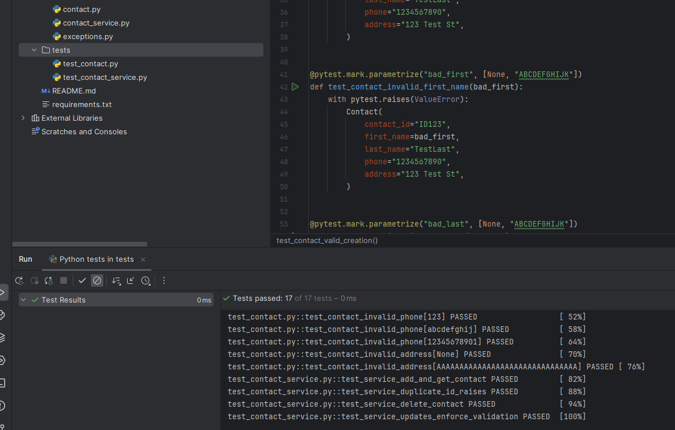
This screenshot demonstrates full test execution and confirms that all validation and service-layer logic behaves as expected under automated testing conditions.
Another important enhancement involved adapting the service layer to handle live form submissions rather than controlled test-driven object creation. When exposing backend logic through a web interface, inputs are no longer guaranteed to be clean or validated. This required additional error handling and input sanitation to ensure that malformed or incomplete form submissions would not destabilize the system.
The Flask interface demonstrates how the same validated logic is reused through a browser-based form while maintaining separation of concerns between presentation and business logic.
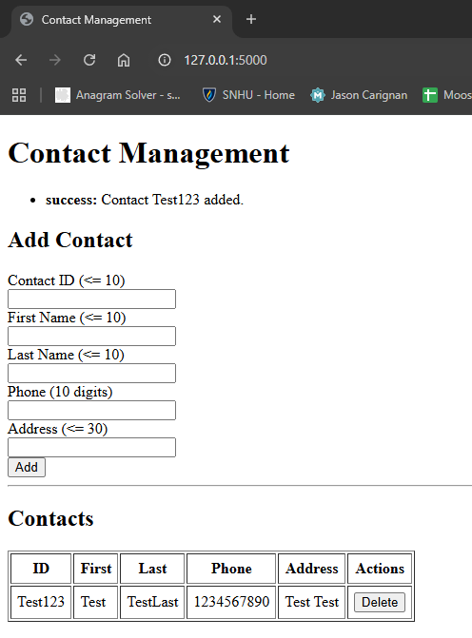
This screenshot shows the user-facing application where contacts can be added and deleted through the browser.
To ensure robustness, explicit error handling was added so that invalid input is gracefully rejected and clearly communicated to the user rather than causing system instability. Validation errors are displayed without exposing internal logic or stack traces.
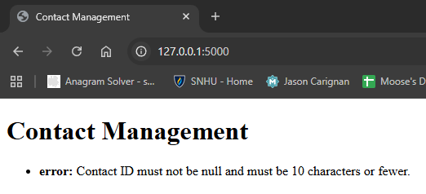
This image illustrates how the system responds to invalid or malformed input, reinforcing the importance of defensive programming and user-safe error messaging.
The decision to use Flask was deliberate. More complex frameworks such as Django provide built-in ORM and authentication features, but for this project, those capabilities would have introduced unnecessary architectural overhead. Flask allowed the backend logic to remain lightweight and modular while demonstrating how validated business rules can be safely exposed through a user interface. The trade-off is that Flask does not inherently provide the scalability or built-in structure of larger frameworks, but for a prototype intended to demonstrate layered design and testing rigor, it was the most appropriate choice. This decision reflects thoughtful framework selection based on scope, complexity, and maintainability.
This enhancement supports the Computer Science program outcomes in measurable ways. The modular structure promotes collaboration by separating the domain model, service logic, testing suite, and interface layers, allowing future developers to extend functionality without altering core validation logic. Professional communication is reflected through clean organization, meaningful naming conventions, structured documentation, and a browser-accessible interface. The enhancement demonstrates evaluation of computing solutions through systematic validation logic and comprehensive testing practices. The deliberate selection of Python, pytest, and Flask reflects thoughtful use of modern tools to deliver functional value. Finally, the explicit validation controls, duplicate detection, and controlled object creation demonstrate a proactive security mindset that anticipates malformed input and protects data integrity.
Overall, enhancing this artifact strengthened my ability to preserve business rules across language boundaries, expose backend systems safely through user interfaces, and evaluate trade-offs in framework selection. The project now reflects a layered, test-driven, and user-accessible system that is far more representative of professional software development environments. This transformation demonstrates growth in architectural thinking, tool selection, validation rigor, and defensive design consistent with modern software engineering standards.

